
国际金融学院
2025金融科技专业本科培养方案
一. 学科专业简介
金融科技专业是专注于金融领域数据分析和包括人工智能在内的前沿技术应用的本科四年制学位专业。
2025年，复旦大学经济与计量经济学专业在QS世界大学排名中位列全球第33位，会计与金融专业排名全球第37位。在泰晤士学科排名中，上述两个学科均为全球第27位。学院金融学科作为国家重点学科，以“扎根中国金融实践、融通全球前沿理论与创新方法，结合现代科技手段，培养兼具国际视野与本土洞察力的复合型金融人才”为特色，形成了理论深度、实践动能与科技融合并重的学科优势。
The Finance and Technology program focuses on data analytics in finance and the application of cutting-edge technologies, including artificial intelligence.
In 2025, Fudan University's Economics and Econometrics program ranked 33rd globally in the QS World University Rankings, while its Accounting and Finance program secured the 37th position worldwide. In the Times Higher Education subject rankings, both disciplines were ranked 27th globally. As a nationally recognized key discipline, the Finance program at our school is distinguished by its commitment to "grounding education in China's financial practices while integrating global theoretical advancements and innovative methodologies, leveraging modern technology to cultivate versatile financial talents with both international perspectives and local insights." This approach has established the discipline’s strengths in theoretical rigor, practical relevance, and technological integration.
二. 培养目标
按照“宽口径、厚基础、重能力、求创新”的人才培养要求，以“2+X+Y”（2是通识和专业教育，X是多元发展路径，Y为融合创新能力）为途径，培养德智体美劳全面发展，具有马克思主义经济学理论基础和金融科技交叉学科知识的高级金融专业人才。毕业生能够任职于投资银行、商业银行、金融科技企业、证券量化机构及政府金融监管部门。
金融科技本科专业是采用英文授课的本科四年制学位专业，构建中外学生同堂互动的国际化课堂，同时为学生提供海外学期交流的发展机会，提升跨文化沟通能力和全球胜任力。
Finance and Technology program cultivates advanced financial professionals with comprehensive development in moral, intellectual, physical, aesthetic, and labor education. Equipped with Marxist economic theoretical foundations and interdisciplinary FinTech knowledge, graduates are prepared for careers in investment banks, commercial banks, FinTech companies, quantitative securities institutions, and government financial regulatory agencies.
As a four-year English-taught undergraduate program in Finance and Technology, it creates an international classroom environment where Chinese and international students study together. The program offers overseas academic exchange opportunities to strengthen cross-cultural communication skills and global leadership competencies.
三. 基本要求
本专业要求学生掌握金融科技的基本理论和基础知识；了解金融市场运行机制与金融科技发展趋势；具有Python编程基础及常用数据分析工具的使用能力；掌握信息整理、金融数据分析、量化建模的基本方法；能够解决金融业务中的常规问题，具备金融科技领域的基础实践能力。
The program requires students to: Master fundamental theories and essential knowledge of FinTech; Understand financial market operations and FinTech development trends; Develop Python programming skills and proficiency in data analysis tools; Acquire methodologies for information processing, financial data analysis, and quantitative modeling; Solve routine financial business problems through foundational practical FinTech capabilities.
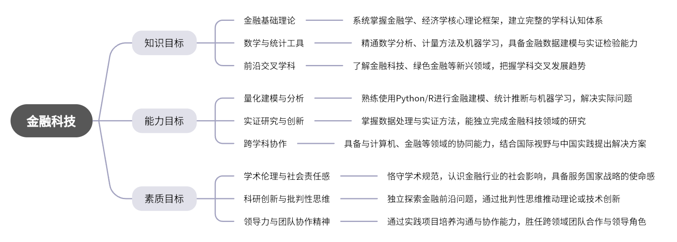
四. 修业要求
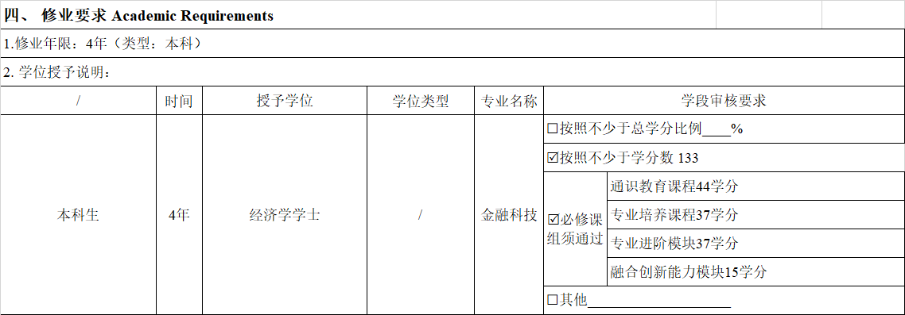
五. 学分要求
1. 专业进阶路径（133学分）
本路径学生需要完成133学分（含实践学分不低于32学分；含美育学分不少于2学分，其中至少在“美学和艺术史论类”或“艺术鉴赏和评论类”课程中修读1学分，并至少参与一项艺术实践活动；劳动教育不少于32学时，并满足劳动周教育要求），包括通识教育课程44学分、专业培养课程37学分、专业进阶模块37学分、融合创新能力模块15学分。
其中要求模块M1至少修读15学分；M2、M3各模块至少修读3学分，M2、M3模块共计修读12学分；M1、M2、M3三模块总计至少修读27学分。若总学分不满37分，可在学校所有本科生课程中任意选修10学分。
Students in this program are required to complete a total of 133 credits, including no less than 32 practical credits, at least 2 aesthetic education credits (with a minimum of 1 credit from either "Aesthetics and Art History" or "Art Appreciation and Criticism" courses, plus participation in at least one art practice activity), and no fewer than 32 labor education hours while meeting the Labor Week requirements. The credit distribution consists of 44 general education credits, 37 core professional training credits, 37 advanced specialization module credits, and 15 integrated innovation capability module credits.
Specific module requirements include: a minimum of 15 credits from Module M1; at least 3 credits each from Modules M2 and M3 (totaling 12 combined credits for these two modules); and an overall minimum of 27 credits across all three modules (M1+M2+M3). Should the total credits fall short of 37, students may freely select up to 10 additional credits from any undergraduate courses offered by the university.
2.跨学科发展路径（133学分）
要求修读2个非本专业独立开设的学程，可选择专业学程或跨学科学程。学分不足部分可在全校所有本科生课程中任意选修。完成学程修读要求的学生可获得相应的学程证书。
Two independent course packages offered by other majors are required, with the option of a major program or a cross-disciplinary program. Any shortfall in credits is to be taken from all undergraduate programs in FDU. A corresponding course package certificate is awarded to those who meet the requirements.
3.辅修学士学位路径
要求至少修读本专业进阶课程M1模块15学分和1个外院系开设的辅修学士学位项目。完成辅修学士学位项目修读要求，且达到学校毕业和学位授予要求的学生可获得相应的辅修学士学位证书。
A minimum of 15 credits from M1 in GBF and a minor in a bachelor's degree program offered by an external school are required. A corresponding minor bachelor's degree certificate is awarded to those who meet the requirements of the program and the university's graduation and degree award requirements.
4.创新创业路径(133学分）
要求修读1个非本专业独立开设的学程和1个创新创业学院开设的创新创业学程，学分不足部分可在全校所有本科生课程中任意选修。
One independent course package offered by another major and one-course package in innovation and entrepreneurship offered by the Innovation and Entrepreneurship Institute are required, with any shortfall in credits to be taken from all undergraduate programs in FDU.
六. 学位要求
（一）本科学位
1. 4年级结束时，如达到学士学位要求者授予经济学士学位。
（1）修满规定的学分，达到本科教学培养方案规定的各项要求。
（2）以符合学生毕业时所在专业教学培养方案规定的所有课程的有效成绩为准计算平均绩点，且此平均绩点大于或等于2.0。
(A) Bachelor's Degree
Students who meet the following requirements by the end of their fourth year will be awarded a Bachelor of Economics degree:
(1) Completion of all required credits and fulfillment of all stipulations specified in the undergraduate program curriculum;
(2) Achievement of a minimum cumulative GPA of 2.0 or above, calculated based on all valid course grades as stipulated by the program curriculum in effect at the time of graduation.
七. 课程体系与科研训练体系
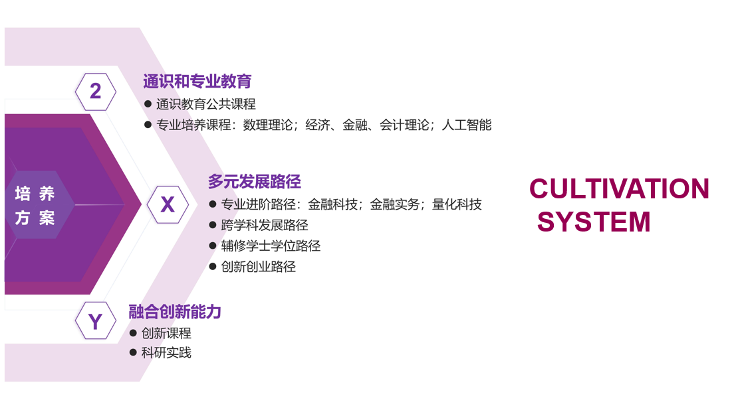
八. 课程设置与修读要求

(一) 通识教育课程（44学分）
1. 通识教育核心课程（28学分）
2. 通识教育专项教育课程（16学分）
(二) 专业培养课程（37学分）
1. 学科基础课程（19学分）
课程名称 | 学分 | 学时 | 修读要求 | 课程代码 | 含实践学分 | 含美育学分 | 含劳动教育总学时 | 开课学期 | 研究生学位课程类别 | 备注
数学分析BⅠ  Mathematical Analysis BⅠ | 5 | 108 | 选修 | MATH10012 | 0 | 0 | 0 | 秋 | / | 允许修读更高难度的中文授课课程  Allows the option to choose higher-level Chinese-taught courses
数学分析BⅡ  Mathematical Analysis BⅡ | 5 | 108 | 选修 | MATH10013 | 0 | 0 | 0 | 春 | / | 允许修读更高难度的中文授课课程  Allows the option to choose higher-level Chinese-taught courses
高等数学A(上）  Advanced Mathematics A I | 5 | 108 | 必修 | MATH10015 | 0.4 | 0 | 0 | 秋 | /
高等数学A(下）  Advanced Mathematics A II | 5 | 108 | 必修 | MATH10016 | 0.4 | 0 | 0 | 春 | /
会计学  Accounting | 3 | 72 | 必修 | BA10003 | 0.75 | 0 | 0 | 秋 | / | 全英语授课
微观经济学  Microeconomics | 3 | 54 | 必修 | ECON20003 | 0 |  |  | 秋 | / | 全英语授课
宏观经济学  Macroeconomics | 3 | 54 | 必修 | ECON20004 | 0 |  |  | 春 | / | 全英语授课
2. 专业核心教育课程（18学分）
课程名称 | 学分 | 学时 | 修读要求 | 课程代码 | 含实践学分 | 含美育学分 | 含劳动教育总学时 | 开课学期 | 研究生学位课程类别 | 备注
公司金融  Corporate Finance | 3 | 54 | 必修 | MF20001 | 0 | 0 | 0 | 3 | / | 全英语授课
投资学  Investments | 3 | 54 | 必修 | MF20002 | 0 | 0 | 0 | 春 | / | 全英语授课
中级微观经济学  Intermediate Microeconomics | 3 | 54 | 必修 | MF20009 | 0 | 0 | 0 | 秋 | / | 全英语授课
计量经济学  Econometrics | 3 | 54 | 必修 | MF20003 | 0 |  | 0 | 春 | / | 全英语授课
计算机导论  Introduction to Computer Science | 3 | 54 | 必修 | MF20006 | 1 | 0 | 0 | 秋 | / | 全英语授课
统计学基础与R软件  Fundamental Statistics and R Software | 3 | 54 | 必修 | MF20007 | 1 | 0 | 0 | 春 | / | 全英语授课
(三) 多元发展课程
1. 专业进阶路径（37学分）
修满37学分。要求模块M1至少修读15学分；M2、M3各模块至少修读3学分，M2、M3模块共计修读12学分；M1、M2、M3三模块总计至少修读27学分。若总学分不满37分，可在学校所有本科生课程中任意选修10学分。
37 credits are required. A minimum of 15 credits is required for Module 1; a minimum of 3 credits for each of Module 2 and Module 3, for a total of 12 credits for M2 and M3; and a minimum of 27 credits in total for M1, M2 and M3. If the total number of credits is less than 37, students are allowed to take any 10 credits from all undergraduate courses in FDU.
(1) 专业进阶模块M1（15学分）
a) M1基础进阶模块（15学分）
课程名称 | 学分 | 学时 | 修读要求 | 课程代码 | 含实践学分 | 含美育学分 | 含劳动教育总学时 | 开课学期 | 研究生学位课程类别 | 备注
金融数据科学和编程  Data Science and Programming for Finance | 3 | 54 | 必修 | MF30005 | 0 | 0 | 0 | 5 | / | 全英语授课
金融科技导论  Introduction to FinTech | 3 | 54 | 必修 | MF20004 | 0 |  | 0 | 春 | / | 全英语授课
中级宏观经济学  Intermediate Macroeconomics | 3 | 54 | 必修 | MF30008 | 1 | 0 | 0 | 6 | / | 全英语授课
金融经济实证分析方法  Empirical Methods in Finance and Economics | 3 | 72 | 必修 | MF30012 | 1 | 0 | 0 | 6 | / | 全英语授课
比较中国金融体系  Comparing China’s Financial System | 3 | 54 | 必修 | MF30001 | 0 |  |  | 春 | / | 全英语授课
(2) 专业进阶模块M2、M3（12学分）
a) M2金融实务模块（3学分）
课程名称 | 学分 | 学时 | 修读要求 | 课程代码 | 含实践学分 | 含美育学分 | 含劳动教育总学时 | 开课学期 | 研究生学位课程类别 | 备注
中国经济  Chinese Economy | 3 | 54 | 选修 | MF30003 | 1 | 0 | 0 | 春 | / | 全英语授课
行为金融学  Behavioral Finance | 3 | 54 | 选修 | MF30006 | 0 |  | 0 | 5 | / | 全英语授课
绿色金融——中国与世界的实践  Introduction to Green Finance in China and the World | 3 | 54 | 选修 | MF40013 | 0 |  | 0 | 春,秋 | / | 全英语授课
金融衍生工具  Derivative Securities | 3 | 54 | 选修 | MF30009 | 0 |  | 0 | 6 | / | 全英语授课
财务报表分析  Financial Statement Analysis | 3 | 54 | 选修 | MF30010 | 0 | 0 | 0 | 秋 | / | 全英语授课
b) M3量化科技模块（3学分）
课程名称 | 学分 | 学时 | 修读要求 | 课程代码 | 含实践学分 | 含美育学分 | 含劳动教育总学时 | 开课学期 | 研究生学位课程类别 | 备注
区块链与数字货币  Block-chain and Digital Currency | 3 | 54 | 选修 | MF40011 | 0 |  | 0 | 春,秋 | / | 全英语授课
社会科学数据挖掘  Data Mining in Social Science | 3 | 54 | 选修 | MF40015 | 0 | 0 | 0 | 春,秋 | / | 全英语授课
机器学习  Machine Learning | 3 | 54 | 选修 | MF30013 | 0 | 0 | 0 | 春,秋 | / | 全英语授课
金融中的数学方法  Mathematical Methods for Finance | 3 | 54 | 选修 | MF20008 | 0 | 0 | 0 | 4 | / | 全英语授课
量化投资：理论与实务  Quantitative Investments: Theory and Practice | 3 | 54 | 选修 | MF40016 | 0 | 0 | 0 | 春,秋 | / | 全英语授课
(3) 任意选修（10学分）
2. 荣誉项目路径（0学分）
3. 跨学科发展路径（37学分）
修满37学分。要求修读2个非本专业独立开设的学程，可选择专业学程或跨学科学程。学分不足部分可在全校所有本科生课程中任意选修。完成学程修读要求的学生可获得相应的学程证书。
学程课程详见教务处学程项目网页，下载地址：https://jwc.fudan.edu.cn/ （复旦大学教务处）专业培养-常用文档。
37 credits are required. Two independent course packages offered by other majors are required, with the option of a major program or a cross-disciplinary program. Any shortfall in credits is to be taken from all undergraduate programs in FDU. A corresponding course package certificate is awarded to those who meet the requirements.
For details on the curriculum of the Cross-disciplinary Track, please refer to the academic website https://jwc.fudan.edu.cn/.
4. 创新创业路径（37学分）
要求修读37学分。要求修读1个非本专业独立开设的学程和1个创新创业学院开设的创新创业学程，学分不足部分可在全校所有本科生课程中任意选修。
创新创业学程课程详见教务处网页，下载地址：https://jwc.fudan.edu.cn/ （复旦大学教务处）专业培养-常用文档。
37 credits are required. One independent course package offered by another major and one-course package in innovation and entrepreneurship offered by the Innovation and Entrepreneurship Institute are required, with any shortfall in credits to be taken from all undergraduate programs in FDU.
For the courses of the innovation and entrepreneurship programs, please refer to the academic website https://jwc.fudan.edu.cn/.
5. 辅修学士学位路径（0学分）
要求至少修读本专业进阶课程M1模块15学分和1个外院系开设的辅修学士学位项目。完成辅修学士学位项目修读要求，且达到学校毕业和学位授予要求的学生可获得相应的辅修学士学位证书。
辅修学士学位项目课程设置详见教务处网页，下载地址：https://jwc.fudan.edu.cn/ （复旦大学教务处）专业培养-常用文档。
A minimum of 15 credits from M1 in GBF and a minor in a bachelor's degree program offered by an external school are required. A corresponding minor bachelor's degree certificate is awarded to those who meet the requirements of the program and the university's graduation and degree award requirements.
For details on the curriculum of the Minor degree, please refer to the academic website https://jwc.fudan.edu.cn/.
其他
多元发展路径中，辅修学士学位项目或专业进阶课程模块均可以冲抵学程，专业培养和多元发展路径共享的课程只计算一次学分。
In the Multi-Development Tracks, either the Minor Degree program or the Regular Major Modules can be offset against the program. Courses shared across the Regular Major Track and Multi-Development Tracks are only counted for credit once.
(四) 融合创新能力（15学分）
课程名称 | 学分 | 学时 | 修读要求 | 课程代码 | 含实践学分 | 含美育学分 | 含劳动教育总学时 | 开课学期 | 研究生学位课程类别 | 备注
领导力课程系列一  Leadership Course Series Ⅰ | 1 | 18 | 必修 | MF10001 | 1 | 0 | 0 | 2 | / | 全英语授课
领导力课程系列二  Leadership Course Series Ⅱ | 2 | 36 | 必修 | MF20005 | 2 | 0 | 0 | 4 | / | 全英语授课
专业实习  Professional Internship | 3 | 54 | 必修 | MF40012 | 3 | 0 | 20 | 春,暑期,秋 | /
毕业论文  Graduation Thesis | 6 | 0 | 必修 | MF40014 | 6 | 0 | 0 | 7,8 | / | 全英语授课
行动学习  Intellection through Action | 3 | 54 | 必修 | MF30011 | 3 | 0 | 0 | 5 | / | 全英语授课
复芏计划(FDUROP) | 0 |  | 选修
国际交流 | 0 |  | 选修
助教助管 | 0 |  | 选修
前沿讲座 | 0 |  | 选修

